Seminar Paper
On

A case study on protecting arable landand boosting up production

Submitted by
Mohammad Shahjalal
Roll no 122
137 ^{th} ACAD Course

Submitted to
Dr. Zohurul Islam,
Module Director



Bangladesh Public Administration Training Centre
Savar, Dhaka

Index
Sl.No | Context | Page No
01 | Abstract | 01
02 | 1.Introduction  1.1Backround  1.2 Objectives  1.3Rationale of the study | 01  01  02  02
03 | 2.Review | 03
04 | 3.Methodology | 05
05 | 4.Result and discussion | 06
06 | 5.Findings | 25
07 | 6.Recommendations | 26
08 | 7.Conciution | 28
09 | 8.Policy implications | 29
10 | 9.References | 29-30

Seminar Paper
On
A case study onProtecting arable land and boosting up production

Abstract:
Bangladesh is a land of agriculture. Agriculture land is contributing to significantfood production. Farmers use land for producing many kinds of crops for the country people. Over the last four-decade cultivableland is gradually decreasing due tomultipurpose works. It is reducing our cultivable land and hampering our agricultural production. It has been observed that multifarious obstacles are prevailing against protecting land. If it is going on this way becomes an acute problem forproduction. The purpose of this research to explore which factors are actually reducing arable land. How to face thischallenges and what action plan shouldbe taken for protecting arable land. Different types of research surveys have been conducted but no result is not still seen for taking more steps to preserve arable land for theagriculture. In this research emphasis has been placed why and what factors are essential for protection and preservationof arable land. It is perceivedthat all stakeholders have to come forward and frame stringent law for protecting agricultural cultivable land.
Keyword: Preserving arable land for sustainable agriculture.
1. Introduction
1.1 Background
Bangladesh is a Deltaic country. Its area is 1,47,570 sq. km which is basically consisted of low and flat alluvial lands. Floodplain land is about 80%, hills about 12% and terrace or uplifted blocks about 8% (Banglapedia). Agro-ecological Zones (AEZ) of Bangladesh is based on land form, soil inundation (hydrology) and climate. In the country there are 30 agro-ecological zones and 88 sub-zones and these zoning are considered as Resource Management Domain (RMD). (DAE, Ministry of Agriculture).
Land is the father of wealth and labor is the mother of land. Bangladesh is predominantlyarchfertile land. It is needless to say that agriculture is still the most important sector in the economy of Bangladesh. Bangladesh agriculture has many aspects distinguishedby its characteristics and technology.
Arable land is particularly important for sustainable food and livelihood. Agriculture cultivable land perform on macro-economic situation like employment generation, poverty alleviation and nutrition attainment. It also ensures food security and rural development.
In our country there are two categories of land, one is agricultural land other is non-agricultural land.
Cultivable land is essential parts of resources and fundamental for food production. Our Cultivable land is 8.5 million hectares. Number of farm holdings is 15.18million.Mono cropped area is 34%,Double cropped area is 53%,Tripled cropped areais13%, Cropping Intensity 216%, Food Production 70.42 million metric tons. (Rice40.71 million metric tons, wheat 1.35 million metric tons, Maize 3.36 million metric tons, Potato 10 million metric tons, Vegetable and Fruits around 10 million metric tons,)Major crops include Rice, Potato, Maize, Wheat, Pulse, Oilseed, Sugarcane, Jute, Vegetable, Fruits, spices, floriculture and mushroom.
The apex body of national agricultural research system(NARS), system of extensions, policy and planning coordination under the ministry of agriculture with the consultation of parliamentary standing committee, ministry of agriculture are relentlessly working to boost up production in Bangladesh agriculture.
1.2 Objectives

- To ensure sustainable production through protecting cultivable land in the country.
- To maintain soil health for sustainable crop production.
- To aware the stakeholders to be involved for protecting agricultural cultivable land.

The seminar paper questions are follows:
- What are the trends of land use between agriculture and non-agriculture?
- How much land is using for agricultural crops production?
- What should we do for protecting arable land?
- What is your outlook to protecting cultivable land boosting up production?
How the seminar paper outputs contribute in policy making?
1.3 Rationale of the study
It is worth mentioning that every year about one percent cultivable land is decreasing (Hasan et al’2013).If it is continuing in our country then the country will soon face a crisis in food production. The present situation is demanding to protect the arable land and ensuring sustainable food security and boosting up the production in Bangladesh Agriculture through Proper use of agricultural land.
Every year twenty lack people are adding in our population. Unplanned land use decreases our agricultural production. Without land zoning and planning of land use, we are misusing our arable land.Fertile cropping land is transforming to other land use like bonding for fisheries. Sometimes it is happened willingly and sometimes farmers are forced to shift their present land use.
We are losing our arable fertile land by top soil removing for brick field. In the southern part people are producing salt in the fertile land which damages the productive land in the name of salt bed. Underground stone and rock harvest isanother reason for losing productive land in the northern part of Bangladesh. Unplanned industrialization every year we are sacrificing our productive land. Not only this untreated affluent is contaminated neighboring agricultural land and is created threat to our future safe agricultural production.
In the southern coastal district saline water creeping to the agricultural crop land in the global changing climate. Therefore 30% of the coastal area becomes in the treat of soil salinity.
Bangladesh needs to protect arable land and boost up production. Stakeholders are to be involved to protect arable land and boost up production through proper utilization of land. There is also a necessity of laws to protect arable land.

Sustainable Development Goal (SDG) 2 is “End hunger, achieve food security and improved nutrition and promote sustainable agriculture”. Bangladesh already achieved self-sufficiency in cereal food production and developed remarkably in other sectors of agriculture. Ensuring sustainable self-sufficiency in nutritious food and doubling agricultural productivity by 2030, protection of agricultural land to non-agricultural use with soil fertility and productivity is essential.
Bangladesh achieved independent under the leadership of great leader Father of the nation Bangabandhu Sheikh Mujibur Rahman.He had taken step and given top most priority to the agriculture sector. He also called for green revolution and emphasized on proper land use and protects arable landforboost up production. Considering the perspective, the study was taken aiming the following objectives.
2. Literature Review
A large number of Bangladeshis are dependent on land-based agricultural activities for their livelihood. In our country land is considered to be a symbol of social prestige and security. In Bangladesh, land still plays a very significant role in both income generation and social life in various ways.In this respectthe proper use of land andstopping misuse of land now a day’s becoming top priority ensuring food security of the country. The Ministry of Land is conducting a range of activities to protect agricultural land and ensure the judicial use of land. Losing arable land is one of the common worries that frequently get in the way of achieving many development objectives there is an element of confusion as to the pace at which arable lands are shrinking.
After the Independent the Government has taken many steps forprotecting agricultural land.Now land ministry has already created digital land zoning maps for realizing present condition all sort of land, framing the Land Use Act, 2012.
National Land zoning has been taken covering remaining 64 districts of 495upazilas including hill tracks areas. In the meantime, digital land zoning maps of most of theupazilas have already been finalized. Validation workshops have already been done and 8 divisional workshops have been completed. During this process, quality and characteristics of land have been taken into account for use in agriculture, livestock farming, forestry, shrimp culture, industry and preservation of biodiversity. Land zoning may favor the government to know the picture of arable land. It will also assist to decision making in this regards.
Soil Resource Development Institute (SRDI) conducted a study with fund by FAO Bangladesh on Agricultural Land Availability in Bangladeshand observed that the total land under cropland in 1976 was 97,61,450 ha which reduced to 94,39,541 ha in 2000, i.e., annual loss is 0.137%. This cropland further decreased to 87, 51,937 ha in 2010, i.e., annual loss of cropland during 2000 to 2010 is 0.728 %(Hasan et al., 2013)
Department of agriculture extension under the ministry of agriculture showing that every year data of cultivation land. It is mentioning that arable land is decreasing gradually. The field service of Department of agriculture extension has prepared about four decade data that we have analysis here.
The country’s lead NGO BRAC conducted a study on cultivable land in the country in 1984 then the agricultural land was 9.2 million hectares. Subsequentstudyhad done in 1996 indicated the decrease in lands amounting to 8.2 millionhectares.The goal to be a middle-income country will not be sustainable if Bangladesh does not have enough land to produce its own food.The finding of Appellate Division of the Bangladesh Supreme Court, “If arable land is not protected, our future will see extinction.”The non-government organization (NGO) Research Initiatives Bangladesh (RIB),operating in the countryside need to supplement the government efforts to develop the agricultural sector which accounts for 16% of the gross domestic product (GDP).
For increasing production our varietal development is going on but cultivable land is decreasing. There is an apparent complacency in recent bumper harvest of paddy. We anticipated that every year our population is increasing .In spite of bumper production we are not in save position because if we are not able to protect our cultivable land.Now credible data are important to know the reasons for the losing land. The reasons are not many but what is the impacts of the loss and what measure are needed to cheek to urgent attention for the concern quarters. A combination of policies and action could help offset the loss to a great extent.
It is possible to land ministry continuous survey the whole country’s land to know the condition of arable land and other purpose use of land. The main activities of the ministry are to update records andland surveys to know the present status of using land. It will help us to project expected production for food security.
The Ministry of Land are guided by policies like ‘National Land Use Policy,2001’; ‘Khas Land Settlement Policy, 1997’; ‘Non-agricultural khas Land Settlement Policy, 1995’; ‘Balu-Mohal and Sand Management Rules, 2011’; ’Chringri-Mohal Management Policy,1998’; ‘Jal-Mohal Management Policy, 2009’; ‘Salt-Mohal Management Policy, 1992’; ‘Vested Property (Amendment) Law,2011’; and ‘The Acquisition and Requisition of Immovable Properties Ordinance,1982’.We have many regulations but now we need a update law protect and preserve arable land in the country.

The main objectives of ‘National Land Use Policy -2011’ are criteria-based uses of land, providing guidelines for usage of land for the purpose of agriculture (Crop production, fish cultivation and 314 rearing of ducks and chickens), housing, a forestation, commercial and industrial establishments, rail and highway and for tea and rubber gardens. Land surveys and preparation of land maps and records, their preservation and publication Demarcation of domestic and international boundaries and repair and preservation of boundary pillars Management land reform and land use policy.
3. Methodology:
There are mainly two approaches to choose as research methodology e.g. qualitative methodology and quantitative methodology. It is also stipulated that there is another option to choose that is mixed method. Mixed methodology includes both qualitative and quantitative methodology. The research employed mixed method.
This research had been conducted how to assess the arable land of Bangladesh. The survey is related to a large number organization in-depth information was provided for the research, so both quantitative and qualitative research methodology was used in terms of the research.
Actually, primary and secondary data werecollected and analyzed to get the answer of the research problem. Semi-structured interview and survey questionnaire technique were used to collect primary/secondarydata; Moreover, Secondary data is collected from related literature review and concern online source. Statistical methods will had been used to analyze information and data collected through survey questionnaire.
4. Results and Discussion:
Agricultural land is one of the determining factors of our economy. We are here presenting the status from 1976 to 2020 using lands of agricultural production. Department of agriculture extension under the ministry of agriculture has prepared about two decade data that we have analysis here.
Land use information 2005-06 to2009-10
. | Subject | Production year
Sl | Subject | 2005-06 | 2006-07 | 2007-08 | 2008-09 | 2009-2010
01 | Total area(sq.km) | 147569.1 | 147569.1 | 147569.1 | 147569.1 | 147569.1
02 | Total area(hector) | 14756910 | 14756910 | 14756910 | 14756910 | 14756910
03 | Total cultivable land (hector) | 9417270 | 9378144 | 9283113 | 9352752 | 9292931
04 | Permanent fallow land (hector) | 1204582 | 1194664 | 1194168 | 1193226 | 1188250
05 | Impermanent cultivable fallow land(hector) | 830072 | 799265 | 790636 | 806222 | 802867
06 | Mono crop land (hector) | 2287538 | 2224930 | 2192063 | 2160986 | 2065274
07 | Dicrop land (hector) | 5022105 | 4817681 | 4816123 | 4814651 | 4810100
08 | Tricrop land (hector) | 2269481 | 2107994 | 2163782 | 2195755 | 2250947
09 | Three plus crop land(hector) | 69645 | 68018 | 70888 | 72062 | 93285
10 | Total cultivable land(hector) | 19418771 | 18456346 | 18599207 | 18665801 | 18811455
11 | Net cultivable land (hector) | 9648769 | 9218623 | 9242856 | 9243454 | 9219606
12 | Intencity of crops (%) | 201.2565 | 200.2072 | 201.2279 | 201.9353 | 204.0375
Source: The field service of DAE.Table-1
Land use information 2010-11to2014-15
. | Subject | Production year
Sl | Subject | 2010-11 | 2011-12 | 2012-13 | 2013-14 | 2014-2015
01 | Total area(sq.km) | 147569.1 | 147569.1 | 147569.1 | 147569.1 | 147569.1
02 | Total area(hector) | 9221713 | 9210960 | 9193296 | 9167940 | 9141105
03 | Total cultivable land (hector) | 1161701 | 1252525 | 1248488 | 1226363 | 1246878
04 | Permanent fallow land (hector) | 1204582 | 1194664 | 1194168 | 1193226 | 1188250
05 | Impermanent cultivable fallow land(hector) | 789866 | 775502 | 761512 | 672964 | 724934.9
06 | Monocrop land (hector) | 1992244 | 1982714 | 1963684 | 1905774 | 1811868
07 | Dicrop land (hector) | 4788824 | 4778683 | 4719054 | 4684734 | 4720863
08 | Tricrop land (hector) | 2322375 | 2348698 | 2415368 | 2485831 | 2517860
09 | Three plus crop land(hector) | 96465 | 103159 | 104310 | 117155 | 130769
10 | Total cultivable land(hector) | 18922877 | 18998810 | 19065136 | 19201355 | 19330250
11 | Net cultivable land (hector) | 9199908 | 9213254 | 9202416 | 9193494 | 9181360
12 | Intensity of crops (%) | 205.6855 | 206.2117 | 207.1753 | 208.8581 | 210.538
Source: The field service of DAE.Table-2.
Land use information 2015-16 to 2019-20
. | Subject | Production year
Sl | Subject | 2015-16 | 2016-17 | 2017-2018 | 2018-19 | 2019-20
01 | Total area(sq.km) | 147569.1 | 147569.1 | 147569.1 | 147569.1 | 147569.1
02 | Total area(hector)
03 | Total cultivable land (hector) | 9016621 | 9002650 | 8980419 | 1248488 | 1226363
04 | Permanent fallow land (hector) | 1206493 | 1193835 | 1208054 | 1194168 | 1193226
05 | Impermanent cultivable fallow land(hector) | 713604.9 | 678271.9 | 682597.9 | 1248488 | 1226363
06 | Monocrop land (hector) | 1805930 | 1732665 | 2390380 | 1772754 | 1928003
07 | Dicrop land (hector) | 4647535 | 4661060 | 4439492 | 4433874 | 4446645
08 | Tricrop land (hector) | 2596845 | 2636657 | 2889501 | 2659603 | 2207020
09 | Three plus crop land(hector) | 138300 | 146012 | 360773 | 1523557.2 | 62822
10 | Total cultivable land(hector) | 19444735 | 19548804 | 21380959 | 19191579 | 17694641
11 | Net cultivable land (hector) | 9188610 | 9176394 | 10080146 | 8999656 | 8644490
12 | Intensity of crops (%) | 211.6178 | 213.0336 | 212.1096 | 213.2479 | 204.693
Source: The field service of DAE.Table-3.
We here collect data from DAE.This data is 2005 to 2020(DAE,Table-1,2&3) about production and using land of the whole country. According to the seminar paper questionsthe field service officer of DAE said; presently urbanization is creating affectson agricultural land. Day by day numerous useof land also decreasing cultivable land.Agricultural land is facing soil erosion,degradation of land and use of industrial, commercial, residential, tourism and all other relative works.Here, Table-1, 2&3 has mentioned the present production and the land using scenario of Bangladesh. The study of current status may be apply for making pragmatic policy to preserving arable land and also support us to face the economic challenges.
Agriculture has a strategic function, because it is the main food supplier for the people in Bangladesh. Different estimation methods of agricultural production provide various data and information. According to official data from Soil Resources Development Institute (Land and Soil Statistical Appraisal Book of Bangladesh, SRDI, 2010) agriculture land covers 9.5 million ha in Bangladesh. Conversely, Bangladesh Bureau of Statistics (BBS) and Department of Agriculture Extension (DAE) stated about 9.1 million ha agriculture land in the Krishi (agriculture) Diary in 2011.
The Yearbook of Agricultural Statistics of Bangladesh (BBS, 2011) mentioned the availability of cultivable land during 1976-77 to 2010-11 (Table 1)

Table 1 Availability of agricultural land during 1976-77 to 2010-11 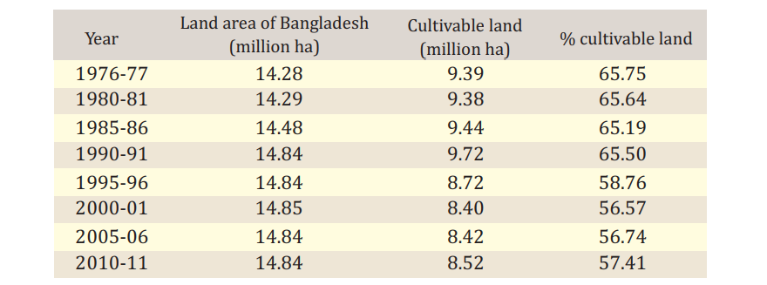

Source: BBS, 2011
Above chart is indicating the circumstances of our country’s land and agricultural land. Agricultural land is the summation of cropped land, current fallow and cultivable waste.Besides this we are usingour land is multi-purpose way.

Cropland:

Cropland included land under cultivated, cultivable waste and current fallow. Total cropland was estimated 9,761,450ha, 9,439,541ha and 8,751,937ha in 1976, 2000 and 2010 corresponding to 67.38%, 64.96% and 60.04% of the total land area respectively (Table 5.1.2). This indicates that cropland decreased more rapidly during 2000-2010 compared to 1976- 2000.

Yearly average cropland decreased 13,413ha (0.14%) during 1976- 2000, 68,760ha (0.73%) during 2000-2010 and 42,063ha (0.30%) during 1976-2010 (Table 5.1.2). Cropland shifting rate is alarming because food security is the main economic and political concern of Bangladesh. Geospatial extent of cropland cover maps of Bangladesh are given in Figure 1

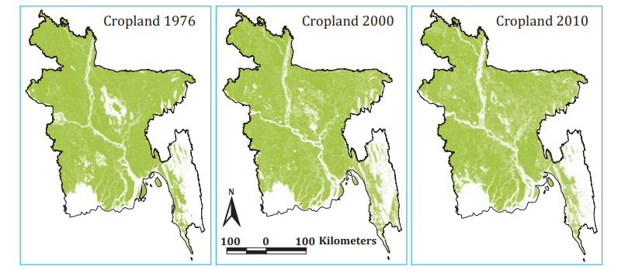
Figure 1 Cropland maps of Bangladesh in the years of 1976, 2000 and 2010, after satellite imagery interpretation.
I visited soil resource development institute. According to the question of my seminar paper collect primary and secondary qualitative data and information that is showing the land condition of Bangladesh (1976 to 2010).Salinity,misuse of land and degradation of land has been seen in northern resign. The stake holder of this area is not aware of this problem.SRDI is carrying out their motivational and awareness program how the people of this resign can proper use of land.
Change in land coverage
Change in land coverage under different categories as plotted in log-log scale during 1976- 2010 is shown in Figure 2.

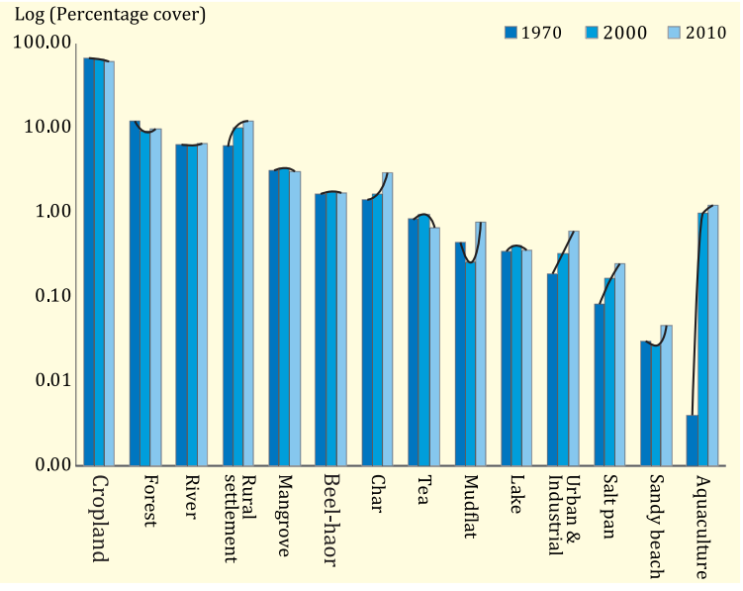
Figure 2 Land cover changes in log-log scale during 1976-2010.
Land use and land cover (LULC) at national level
The area of Bangladesh represents 144,873, 145,306 and 145,778km2 during 1976, 2000 and 2010 respectively (Table 2). Overall land gain was 905km2 (90,512ha) during 1976 to 2010 due to accretion in the southern coastal zone of Bangladesh. The land cover of the country was divided into two categories i.e. agricultural land and non-agricultural land.

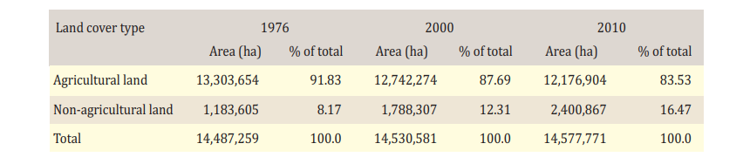Table 2 Total land area of Bangladesh, based on Land satellitedata.SRDI explained that coastal area’s land are sometimes gaining or sometime also losing land.
Agricultural land in Dhaka division:
Major land cover changes of Dhaka division during 1976-2010 are shown in Table 3. Most of the lands in Dhaka division have been used as cropland with declining trend of 2,313,751ha in 1976, 2,312,961ha in 2000 and 2,161,650ha in 2010. Average yearly loss of cropland was 33ha (0.001%) during 1976-2000, 15,131ha (0.65%) during 2000-2010 and 4,474ha (0.19%) during 1976-2010.
Forest area is being estimated 300,753ha, 133,532ha and 91,930ha in 1976, 2000 and 2010 respectively. Yearly average decreased 6,968ha (2.32%) during 1976-2000, 4,160ha (3.12%) during 2000-2010 and 6,142ha (2.04%) during 1976-2010. The river area remains almost static during the study period (1976-2010). Yearly average rural settlement increased 2.25%, 4.78% and 3.75% during 1976- 2000, 2000-2010 and 1976-2010 respectively. Among non-agricultural lands, rural settlement occupied the highest area that increased more than two-fold during 1976-2010.
The data indicates that land gained in rural settlement was 5,077ha (2.25%), 16,626ha (4.78%) and 8,474ha (3.75%) annually during 1976-2000, 2000- 2010 and 1976-2000 respectively. The area occupied by urban and industrial zone increased 10,190ha in 1976 to 22,795ha in 2000 and further 42,747ha in 2010. Land gained in urban and industrialization was much rapid during 2000-2010 compared to 1976-2000 and estimated 1,995ha annually.Table 3 Remote sensing image-based analysis of major land cover changes in Dhaka division, 1976–2010
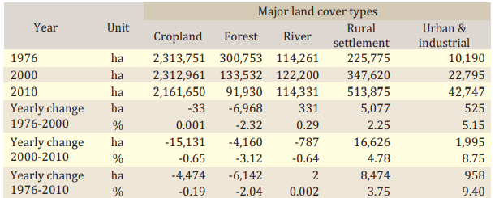
Analysis of the above table it is showing that the settlement of Dhaka division and other district of the Dhaka division are using land rapidly for rural settlement,industrialization and other need based necessities.
Agricultural land in Chottogram division:
The land changing scenerio of Chittagong division during 1976-2010 are shown in Table 4. The highest area in Chottogram division is covered by cropland with declining trend of 1,366,983ha in 1976 to 1,365,756ha in 2000 and further to 1,186,076ha in 2010. Average yearly loss of cropland was 51ha (0.004%) during 1976-2000, 17,968ha (1.32%) during 2000-2010 and 5,321ha (0.39%) during 1976-2010. SRDI is explaining that this reducing rate is less than Dhaka division but multi-purpose use of land is gradually reducing cultivable land.
Forest land is estimated 1,380,402ha, 1,116,258ha and 1,316,104ha in 1976, 2000 and 2010 respectively. Yearly average forest area decreased 9,076ha (0.66%) during 1976-2000 but increased 15,358ha (1.32%) during 2000-2010 and again decreased to 1,891ha (0.14%) during 1976-2010. Yearly average river area increased 0.41%, 0.55% and 0.47% during 1976-200, 2000-2010 and 1976- 2010 respectively. Among non-agricultural lands, rural settlement occupied the largest area that increased more than two-fold during 1976-2010.
The data indicates that land gained in rural settlement was 7,266ha (4.61%), 1,233ha (0.37%) and 5,491ha (3.48%) annually during 1976-2000, 2000-2010 and 1976-2000 respectively. Urban and industrial area increased 2.31% during 1976-2010 and 5.73% during 2000-2010. The land gained in urbanization and industrialization was faster during 2000-2010 compared to 1976-2000 and estimated 765ha annually.
During our data collection period, SRDI comments that Chittagong is port city and it also called commercial city of Bangladesh. The necessity of the demand like economic zone and other crucial project for the people.There land is using numerous developments. As a result, the arable land is reducing.
Table 4 Remote sensing image-based analysis of major land cover changes in Chittagong division, 1976–2010
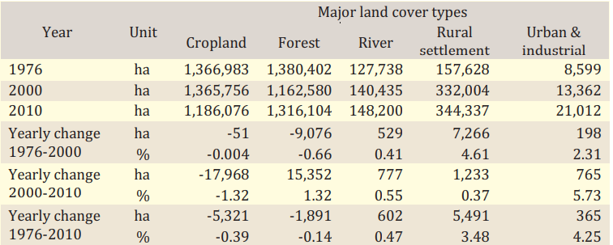
Agricultural land in Rajshahi division:
In Rajshahi division during 1976-2010 are given in Table 5.Like other divisions, the major area has been used as cropland with declining trend of 1,552,558ha in 1976 to 1,436,307ha in 2000 and further declined to 1,276,861ha in 2010. Average yearly loss of cropland was 4,844ha (0.31%) during 1976-2000, 15,945ha (1.11%) during 2000-2010 and 8,109ha (0.52%) during 1976-2010. Forest area was only 9,834ha in 1976 which completely declined by 2000 and no forest land identified in 2010 images. Yearly average river area increased 1.58%, 1.62% and 1.77% during 1976-200, 2000-2010 and 1976-2010 respectively,

Indicating incessant riverbank erosion particularly along the river Padma. Almost all non-agricultural land’s are occupied by rural settlement that increased more than two-fold during 1976-2010. Here data analysis reveals that land gained in rural settlement was 3,033ha (2.59%), 7,021ha (3.70%) and 4,206ha (3.59%) annually, during 1976-2000, 2000-2010 and 1976- 2000 respectively. Urban and industrial area increased 0.06% during 1976- 2010 and 7.41% during 2000-2010. The land gained in urbanization and industrialization was faster during 2000-2010 to 1976-2000.
Table 5 Remote sensing image-based analysis of major land cover changes in Rajshahi division, 1976–2010
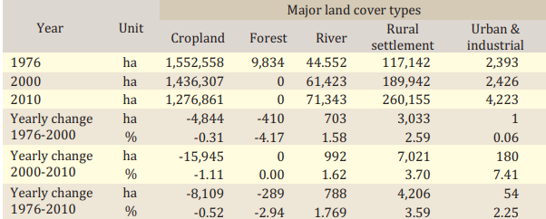
Agricultural land in Khulna Division
In table 6are given in 1976-2010 that has changed the land of Khulna division.The cropland declining trend is 1,330,485ha in 1976 to 1,322,039ha in 2000 and further declined to 1,234,229ha in 2010. Yearly average loss of cropland was 352ha (0.03%) during 1976-2000, 8,781ha (0.66%) during 2000-2010 and 4,011ha (0.21%) during 1976-2010.
According to survey report of SRDI, Geo-spatial data reveals that natural mangrove forest of Sunder ban covers 409,646ha in 1976 which slightly increased to 415,047ha in 2000 due to natural regeneration. In the meantime when the human interferences increase and effect of natural disasters decreased forest to 400,021ha in 2010.
Yearly average river area decreased by 0.26% during 1976-2000 but it increased by 0.38% during 2000-2010.Trends in the availability of rural settlement increased during 1976- 2000 at the rate of yearly 517ha (0.37%) but it decreased annually 654ha (0.43%) during 2000-2010. Urban and industrial zone increased more than three-fold in Khulna division during 1976-2010. Yearly land gained in urban and industrial area was 44ha (2.54%) during 1976-2000 and 249ha (8.94%) during 2000-2010 which has deducted from land and agricultural land.

Table 6 Remote sensing image-based analysis of major land cover changes in Khulna division, 1976–2010

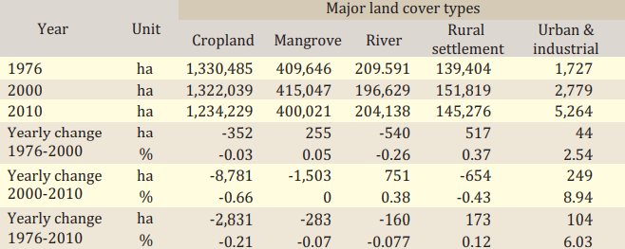
Arable land scenario in Barisal division
The land changes of Barisal division during 1976-2010 are presented in Table 7.The cropland declining trend of 844,141ha in 1976 to 820,671ha in 2000 and further declined to 814,010ha in 2010. Yearly average loss of cropland was 978ha (0.12%) during 1976-2000, 666ha (0.08%) during 2000-2010 and 886ha (0.10%) during 1976-2010.
The planted mangrove forest was 22,208ha in 1976 which increased to 37,132ha in 2000, SRDI indicating that the pioneer success of coastal a forestation programs in specific ecological zones on the islands, the coastal and riverine shorelines and in the upland locations. Human encroachment, degradation and extreme climate events are the drivers to decrease mangrove forest to 21,292ha in 2010.Ultimately land is decreasing by manly activities and natural calamities. Besides this other area of Barisal division land is losing for river erosion and development activities.Salinity problem also a major problem in Barisal division.

River area decreased annually by 0.28% during 1976-2000 but it increased annually by 0.14% during 2000- 2010.Trends in the availability of rural settlement and new road construction increased in Barisal division during 1976-2000 at the rate of annually 1,455ha (2.47%) but decreased at the rate of 386ha (0.41%) annually during 2000-2010. Urban and industrial zone increased fivefold during 1976-2010. Data analysis shows that land lost in urban and industrial area at the rate of 11ha (3.11%) during 1976-2000 and again it gained at the rate of 176ha (201.72%) during 2000-2010.Every year urban and industrial settlement decreases cultivable land.It is now a common phenomena all over the Bangladesh.
Table 7 Remote sensing image-based analysis of major land cover changes in Barisal division, 1976–2010
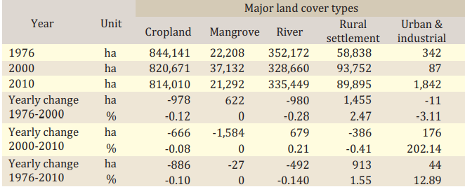
Cultivable land scenario in Sylhet:

It is exceptional in Sylhet division, during 1976-2010 are given in Table 8. Like other divisions, major area is covered by cropland which was 945,506ha in 1976 with a gradual decreased to 831,227ha in2000 and 839,371ha in 2010. Yearly average loss of cropland was 4,762ha (0.50%) during 1976-2000 and 814ha (0.10%) during 2000-2010. Overall yearly lost of cropland was 3122ha (0.33%) during 1976-2010.SRDI pointed outthat each year human accommodation and multifarious business is declining arable land. Despite of yearly average forest area decreased 1,358ha (3.04%) during 1976-2000 but thereafter it is increased 1,138ha (9.42%) during 2000-2010.

River area was decreased continuously by 0.58% annually during 1976-2000. Trends in the availability of rural settlement increased annually 4450ha (4.89%) during 1976-2000 and further increased 1,932ha (0.98%) during 2000-2010. The rate of increase was much higher during 1976-2000 compared to 2000-2010. However, a rapid increase of urban industrial and commercialarea was noticed between 2000 and 2010.

Table 8 Remote sensing image-based analysis of major land cover changes in Sylhet division, 1976–2010
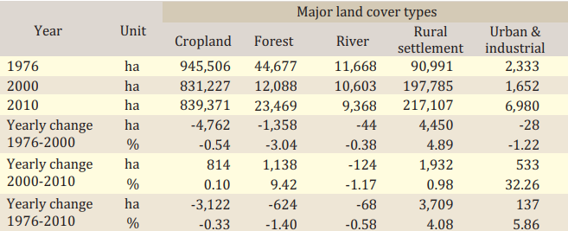
Arable land scenario in Rangpur division:
Rangpur division during 1976-2010 are shown in Table 9. The greatest area is covered by cropland with declining trend of 1,408,175ha in 1976 to 1,350,730ha in 2000 and further decreased to 1,239,768ha in 2010. Annual declination rate is much faster in 2000-2010 (0.82%) compared to 1976-2000 (0.17%). Forest land is being estimated 18,634ha, 2,921ha and 2,632ha in 1976, 2000 and 2010 respectively. Forest area decreased annually 655ha (3.51%) during 1976-2000 and 29ha (0.99%) during 2000-2010. Yearly average forest lost was observed 471ha (2.53%) during the past 34 years (1976-2010).As a result cropland land is declining due to increasing population.

Area under river showed fluctuating trends that decreased greatly from 1976 to 2000 and thereafter increased two folds from 2000 to 2010.Among non-agricultural lands, rural settlement occupied the greatest area that increased more than two-fold during 1976-2010. Data analysis displays that rural settlement increased 2,052ha (2.14%) and 5,044ha (3.48%) annually during 1976-2000 and 2000-2010 respectively.

The area occupied by urban and industrial zone increased from1,217ha in 1976 to 4,395ha in 2000 which further increased to 5,549ha in 2010. Practically urban and industrial area increased more than four times during 1976 to 2010.Table 9 Remote sensing image-based analysis of major land cover changes in Rangpur division, 1976–2010
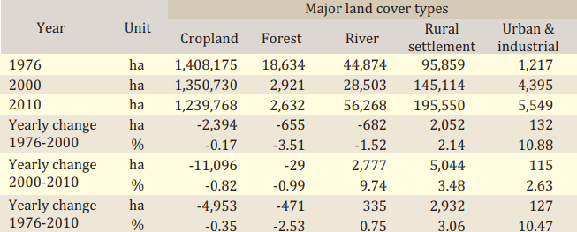

Finally, analyzing all divisions data it is revealed that annual loss of cropland during 1976-2000 was 13,413ha which continues to 68,760ha during 2000-2010. Considering cropland irrespective of the percentage of total landmass of the country, the total land under cropland in 1976 was 9,761,450ha which reduces to 9,439,541ha in 2000, i.e., annual loss is 0.137%. This cropland further decreases to 8,751,937ha in 2010, i.e., annual loss of cropland during 2000 to 2010 is 0.728 %. Highest annual loss of crop land occurs in Chottogram Division and at the rate of 17,968ha. Annual loss of cropland in Rajdhani, Dhaka, Rangpur, Khulna and Barisal were 1,5945ha, 15,131ha, 11,096ha, 8,781ha and 6,661ha respectively.

Comparative study of divisional wise land scenario has been displayed and analyzed. It is showing the whole land scenario of Bangladesh. This result of study assist the any concern authority to framing the policy and decision making purpose is true that Every year gradually average 1% agricultural land is declining for use of other purpose.

On the other hand, annual increases of rural settlements were 23,850 and 30,809 ha per year during 1976-2000 and 2000-2010 respectively. Highest annual growth of rural settlement observed in Dhaka Division which is 16,626ha during 2000-2010. Rajdhani and Rangpur secure the second and third position. Annual increase of urban settlement and industrial area increases by 4,012ha per year during 2000- 2010.It is opined that highest agricultural land is decreasing in Dhaka division, Rajshahi secure the second and third position is rangpur.
It had been seen that significant loss of forest land observed during 1976-2000, but on the other hand forest land increases significantly during 2000-2010, this may be because of the initiatives by the government, awareness among the peoples especially of social forestry. Coastal plantation initiatives increased the mangrove area during 1976-2000 but it decreased largely during 2000-2010 due to human interferences, encroachment and tropical cyclones. Annual increases in aquaculture during 1976-2000 were observed 5,955habut forth period 2000-2010, the increase took place by 3216ha per year.
Figure 2depicted land cover dynamics at national level during 1976-2010.

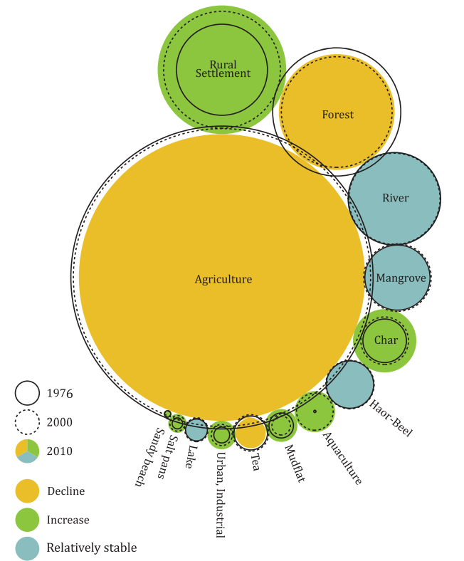Figure 2 Land cover dynamics at national level during 1976-2010.
Land Use Changes
Based on SRDI database of Land and Soil Resources Utilization Guides popularly known as UpazilaNirdeshika prepared during 1985 to 2002 and subsequently published, total land area (total arable land) was estimated 95,98,381 hectares or 65.05 percent of Bangladesh. They described that yearly average decrease of crop land during 2000 to 2010 was 0.73 percent. The present study is based on database of second generation of Upazila Nirdeshika published up to 2018
Sundarban comprises 2.90 percent, ReserveForest comprises 1.93 percent and others including homestead, rivers, urbans comprise 30.13 percent of Bangladesh (Land and Soil Statistical Appraisal Book of Bangladesh, SRDI, 2010). Another study conducted by Hasan et.al.,2013, showed that in 2010, cropland covers 8,751,937 hectares of land comprises 60.04 percent of Bangladesh, Sundarban comprises 3.03 percent and forest including reserve forest comprise 9.48 percent of Bangladesh. Their study was conducted through digital interpretation of satellite imagery, secondary information and ground truthing in selected location in Bangladesh. They also studied the same for 1976 and 2000.
In this study it showed that crop land covers 8,586,864 hectares of land comprises 58.09 percent of the country, which is less than 6.85 percent that that of 2010 and annual average decrease of crop land is 0.685 percent and lesser than the study made by Hasan, et.al., 2013. This difference may be due to the methodology of the study or transfer of crop land to aquaculture became saturated and government policy and enactment. More over may be of shifting of crop land to rural settlement is lesser than that of 2000 to 2010. Land use changes during 2010 to 2020 are shown in figure 3 and Table 10.

Fig 3.Changing pattern of land use of Bangladesh since 2010 to 2020.

Table 10 Change in land use (area and percentage) since 2010 to 2020
Land use type | 2010 |  | 2020
Land use type | Area (ha) | Percent (%) | Area (ha) | Percent (%)
Crop land | 9598381 | 65.04 | 8586864 | 58.19
Sundarban | 427418 | 2.90 | 409999 | 2.78
Reserve forest | 284210 | 1.93 | 130345 | 2.10
Homestead, rivers, urban and others | 4446991 | 30.13 | 5449792 | 36.93
Total | 14757000 | 100 | 14757000 | 100
Creeping Saline water in Crop land
More than 30% of the cultivable land of the country is in the coastal areas. Soil salinity is in increasing trends with time (Table 11). The soil salinity maps 1973 and 2009 (Figure 4) indicate that soils of Jessore, Magura, Narail, Faridpur, Gopalgonj, Barisal, Jhalakhati and Patuakhili have been newly salinized during 36 years and the salinity area has increased to 1.056 mha in 2009 from 0.833mha in 2000 (Ahsan and Sattar, 2010).
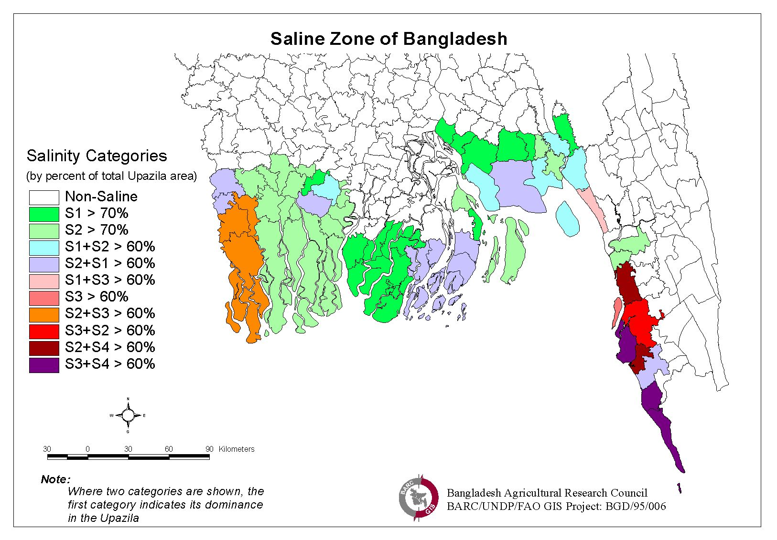
Figure 4. Saline zone of Bangladesh.

Table11. Increase of soil salinity in coastal areas during 1973 to 2009

1973  (000,ha) | 2000  (000,ha) | 2009  (000,ha) | Salt affected area increased during last 9 years(2000-2009) (000'ha) | Salt affected area increased during last 36 years (1973-2009) (000'ha)
833.45 | 1020.75 | 1056.19 | 35.44 (3.5%) | 222.74 (26.7%)

Source:Ahsanand Sattar, 2010
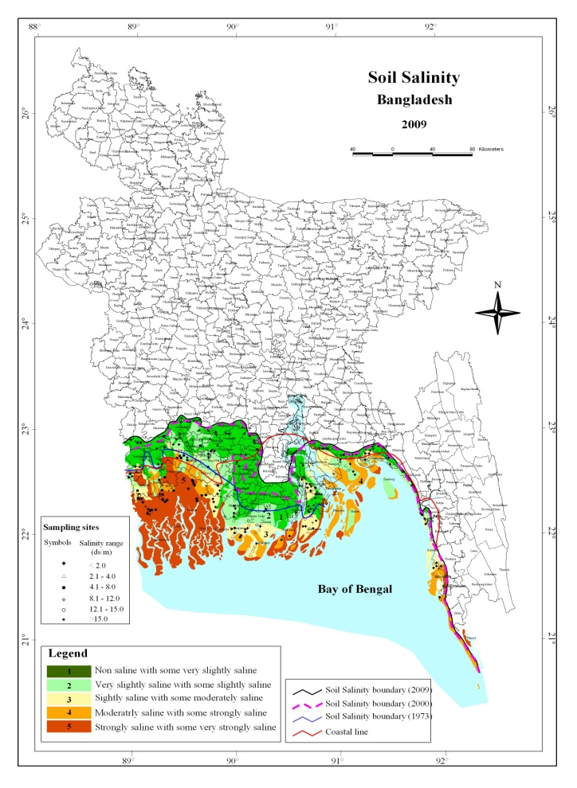
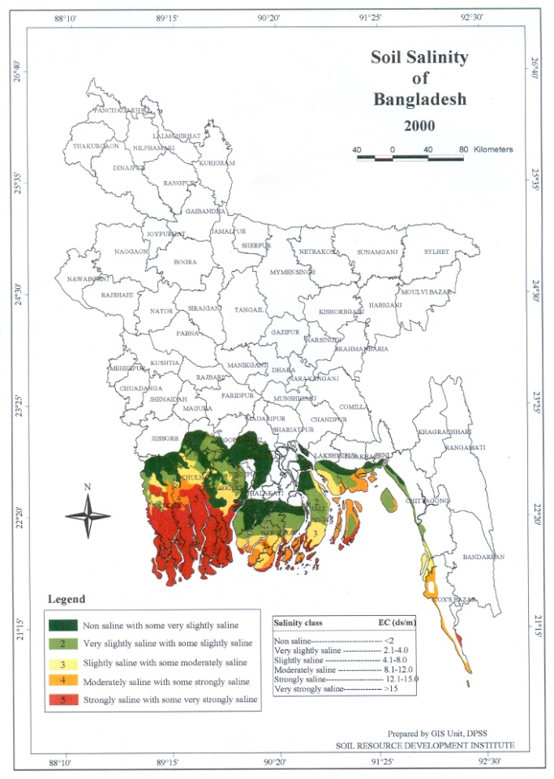

Figure 5. Soil salinity map of Bangladesh of the year 2000 and 2009. (Source: SRDI, 2010)
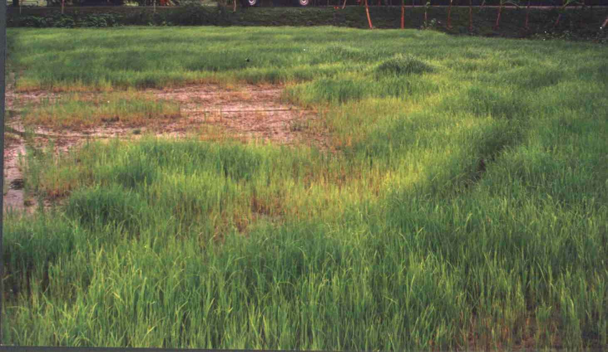
Figure 6. Spatial variation of soil salinity in a field at Char Majid.
Changing climatic parameters and agro-ecosystem
A changing climate will affect agro-ecosystems in heterogeneous ways, with either benefits or negative consequences dominating in different agricultural regions. However, the factors that prevail regionally may change over time, as gradual and possibly abrupt climate changes develop in this century. Rising atmospheric CO₂ concentration, higher temperature, changing patterns of precipitation, and altered frequencies of extreme events will have significant effects on crop production (Table 12), with associated consequences for water resources and pest/disease distributions.
Table 12. Climatic parameters changing scenarios
Variables | Climate Change
Variables | Slow | Extreme
Average temperature increases (⁰C) | + 02 | + 04
Sea level rise (cm) | + 30 | + 100
Rain fall (%)  Rainy season  Dry season | + 18  - 12 | + 33  - 22
Evaporation (%)  Rainy season  Dry season | + 08  + 10 | + 15  + 20
River Water flow (%)  Maximum flow  Minimum flow | + 06  - 12 | + 13  - 22
Storm Intensity (%) | + 10 | + 25
Source: IPCC, 1996
Coastal area affected by inundation due to sea level rise
Based on the geographical structure like low elevation to the land areas, the low inclining of the rivers, and approximate to the sea, Bangladesh is one of the most susceptible countries to the effects of sea level rise and climate change. One-meter sea level rise will inundate about 5,608 million acres of existing coastal land which is about 15 percent of the total areas of Bangladesh.

The area comprising of 65 percent of greater Khulna, 99 percent of Barisal, 100 percent of Patuakhali, 44 percent of Noakhali and 12 percent of Faridpur will be inundated and as a result 13.74 percent of net cropped area and about 401,600 hectares of mangrove forest along with its wild life will be vanished (Table 13).
Table 13. The area of the coastal area which supposed to inundate due to one (1) meter sea level rise
Region | Area (%)
Khulna | 65
Barisal | 99
Patuakhali | 100
Noakhali | 44
Faridpur | 12
Source: Hossain, 1991
5. Findings:
- Looking at the overall situation, it appears that loss of land could have been protected by a legal bar on the use of agricultural land for the purpose of cultivation. we have a lot of legal bar but it has not been in this respect. Concern quarters are not strongly expressed their opinions in the past in favor of legal instrument to protect agricultural land.
- Update survey and study is not prevailing in the country. The continuous study and statistics should be measure for saving agricultural arable land.Goverment is not taking steps to protecting cultivable land.
- Public awareness program and update land policy is not properly propagating in the country to preserve land for agricultural development.
- Till now no system has not been expedite and modernize for taking decision. If arable lands are destroyed in the name of development project it would create a serious threat for food security in future. No effective strategy has not been taken to cheek the countries fast shrinking arable land.
- Water logging problem also hampering food production and river erosion decreasing arable land.Sometimes, using block and bolder to protect river embankment that is increasing high the river level. As a result, large number area has been inundating.
- Lack of accurate statistics of arable land and update data has not seen.
- More technological application is not using for accurate land survey.Like Drone Bangabandhu satellite and Nano technology.
- Land reclamation process is not applying to increase the arable land.
- Horizontal cultivable land is using for housing purpose. It is decreasing our arable land. Lack of inspiration for vertical expansion. Frame a law of land ceiling for accommodation or building.
6.Recommendations:
- Public awareness program and update land policy should be properly propagating in the country to preserve land for agricultural development.
- Giving emphasis on inter-ministerial meeting that can make a significant role to protect cultivable land.
- “Protection and Usage of Agricultural Land Bill, 2022” has been placed in the Jatiya Sangsad (JS) to ensure the proper use and protection of the country’s agricultural land. The enactment of the bill is necessary for the protection of the arable land; otherwise, the country in future will face a serious shortage of food production.
- There is no accurate statistics of arable land and update data of arable land.
- More technological application should be use for accurate land survey.like Drone Bangabandhu satellite and nano technology.
- Decline in arable land is worrisome. The suggestion to the authorities concerned should go for regular surveys of arable land to present an accurate figure so that necessary steps in this regard. It is quite a gigantic task, but it should be done at regular intervals.
- We can useBangabandhu satellite for how much land we areusing? Acquiring the data of proper crop land condition whichcan we relevantly use it for research and development issues. Use of satellite can give us pragmatic data of agricultural arable land.
- Riverine land reclamation process can increase the arable land. It would be assisting to protect river erosion. Riverdredging can promote land reclamation, protect river erosion and also protect embankment of the river.
- Vertical expansion should beenhancingfor housing purpose. It would beincreasing our arable land. Frame a law of land ceiling for accommodation or building.
Implementation action-log
Sl | Actions | Responsibility | Timeframe | Resource required
01 | Framing stringent law | Ministry of Land, Ministry of Agriculture and Law ministry. | 2 year | to be estimated
02 | Public awareness program and update land policy should be properly propagating in the country to preserve land for agriculture. | Ministry of Land, Ministry of Agriculture | 3 years | to be estimated
03 | Inter-ministerial meeting will make a significant role to protect cultivable land. | Ministry of Land, Ministry of Agriculture | Every three month | to be estimated
04 | accurate statistics and continuous survey have to commence on protecting arable | Ministry of Land, Ministry of Agriculture | 3 years | to be estimated
05 | Use update technologyand instruments for all kinds of lands. | Ministry of Land, Ministry of Agriculture and ICT Ministry. | 3years | to be estimated
06 | Stakeholder have to come forward for protecting cultivable land in terms of food security of the country. | Ministry of Land, Ministry of Agriculture | every three month | to be estimated

7. Conclusions:
In spite of having number of limitations, Bangladesh economy is moving ahead. In the last ten years the economic growth is around six percent. The food security situation is quite good at this moment. Bangladesh has achieved self-sufficiency in producing rice (USAID). However, we have to think about the future. With the report of BBS, my study will show that, agricultural land has decreased over the last forty years. If the present decreasing trend continues, in 2050 the per person land availability might be only 0.037 hector with 202 million population. In that time, we have to manage food for this huge population with only 7.51 million hectares of land.
So, it will be a real challenge for Bangladesh. However, the study will show that, if crop productivity increases at present rate or near about present rate, agricultural land decrease does not seem to be a potential threat to the Bangladesh Agriculture. Other study suggests that, rather we have to be much concern about soil health and rapid rural settlement. Simultaneously, our study indicates that we have to put more attention for inventing new land it may be reclamation or other ways to minimize the decreasing land with the ratio of food production. Our study finding differs slightly with methodological difference and data time period. This study can be improved by using sophisticated way of Forecasting by considering more issues regarding agricultural production and cultivable land.
8. Policy implications:
We have to formulate the terms of land use in rural areas. "The government should introduce community living system in certain rural areas like European countries. Before it, a law is needed and the law should be applied strictly. Hence, we can save our arable lands and production will increase. The government must give importance on arable land while giving permission to allow any industrial or development work, "Our land is very limited, it would create a major impact on country's food security."
It is the agriculture sector of Bangladesh that plays the most vital role in the development of the economy. We are not only feeding the million mouths but also ensuring their livelihood. Above steps can help us protect agricultural land and boost up production we have numerous challenges but we have enormous potentialities and prospects as well. All our endeavors are directed towards translating the challenges into potentialities. We don't have any other options but to succeed. All of us are looking forward towards a prosperous Bangladesh and a hunger free world without human sufferings.
6.References
Abul Barkat, Rowshan Ara, M. Taheruddin, Saiful Hoque and Nazrul Islam, 2007. Towards a feasible land use policy of Bangladesh, Human Development Research Centre (HDRC), Dhaka.

Ali, A.M.S., (1995). Population pressure, environmentalconstraints and agricultural changes in Bangladesh example three agro-ecosystems. Agric. Ecosyst. Environ 55, 95-109.

Banglapedia, 2021.

BBS, 2000. Yearbook of Agricultural Statistics of Bangladesh, Ministry of Planning.
BBS, 2011. Yearbook of Agricultural Statistics of Bangladesh,Ministry of Planning.
(BBS, 2012. Yearbook of Agricultural Statistics of Bangladesh,Ministry of Planning.
BBS,1986. Yearbook of Agricultural Statistics of Bangladesh, Ministry of Planning.

DAE, Ministry of agriculture.

Financial Express, 21 August 2019.

Hasan, M.N., Bari, M.A. and Lutfar, M.R. 2020. Guideline for Soil Fertility Degradation Study including Identifying Soil Fertility Trends and Measures. SRSRF project. SRDI. Dhaka.

Hasan, M.N., Hossain, M.S., Bari, M.A. and Islam, M.R., 2013. Agricultural land availability in Bangladesh. SRDI, Dhaka, Bangladesh, 42 pp.
M. Ahsan and M.A. Sattar, 2010. Coastal areas and saline soils of Bangladesh: their extent, salinity status, management practices and future research needs. Paper presented in the Workshop on Soil Fertility, fertilizer Management and Future research Strategy, held at BARC, during 18-19 January, 2010.
Ministry of land.

SRDI, Ministry of agriculture.

The New Nation, 15 June 2022.

